Cllr Susan Aitken 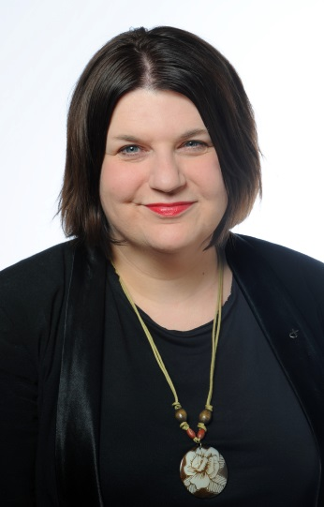
Glasgow City Council Representative

Susan Aitken became Leader of Glasgow City Council when the SNP became the largest party on the Council and formed a minority administration in May 2017. She was elected as a councillor for the Langside ward, where she lives, in 2012 and has been leader of the SNP group since 2014, having previously served as the group spokesperson on health and social care. She is the SNP’s national Local Government Convener.
Before being elected, Susan worked in a variety of policy and research roles in the Scottish Parliament and the third sector, and as a freelance writer and editor specialising in health and social care policy. She grew up in Biggar in South Lanarkshire, moved to Glasgow aged 17 and is a graduate of both Glasgow and Strathclyde Universities.

